ESHAAL ATIF(SP24-BSCS-0087)

DUA ASHFAQ((SP24-BSCS-0079)

USE CASE DIAGRAM

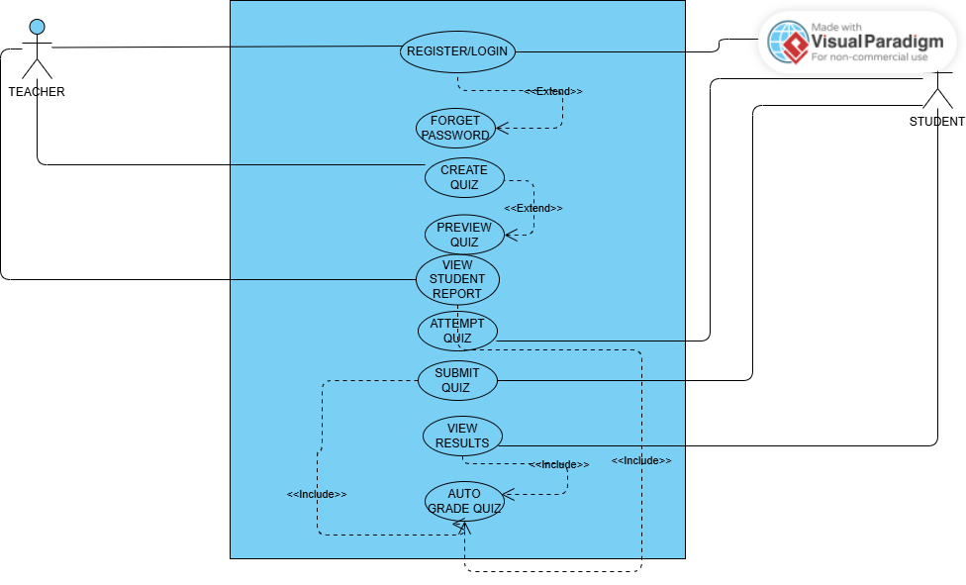

CLASS DIAGRAM

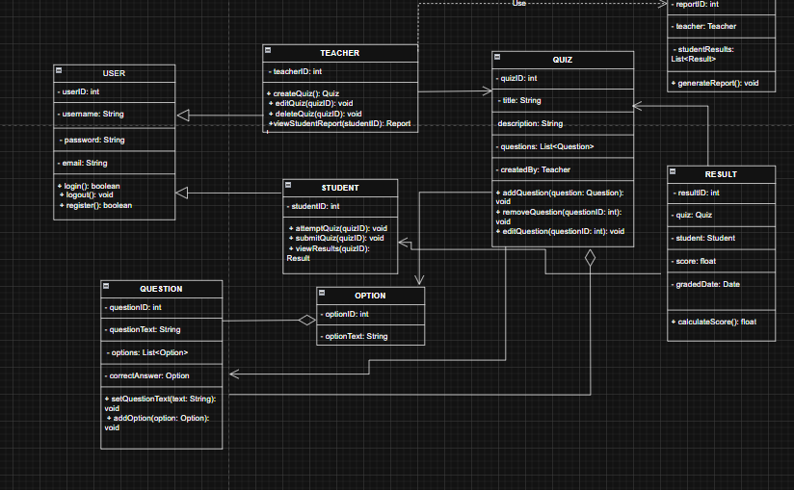

https://drive.google.com/file/d/1cn4maN2P3L6p7zHSYpfOtSXZN-tD_1ya/view?usp=sharing

Class Activity

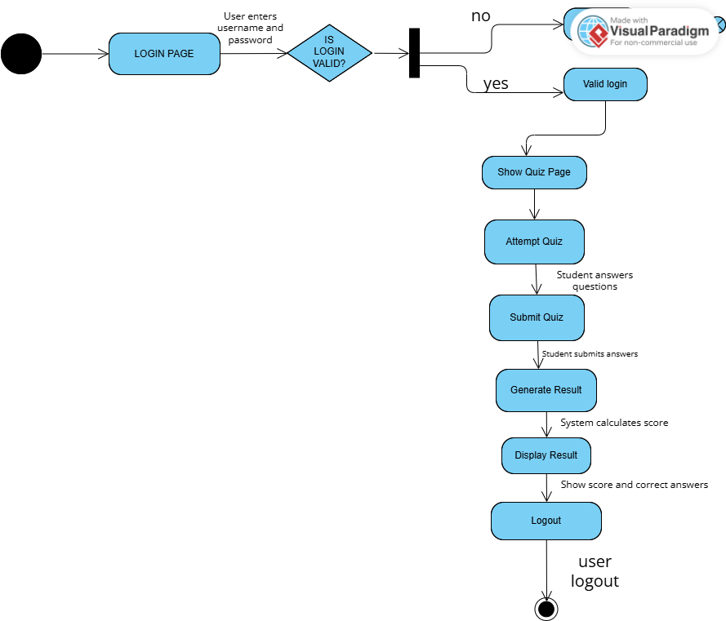

SEQUENCE DIAGRAM

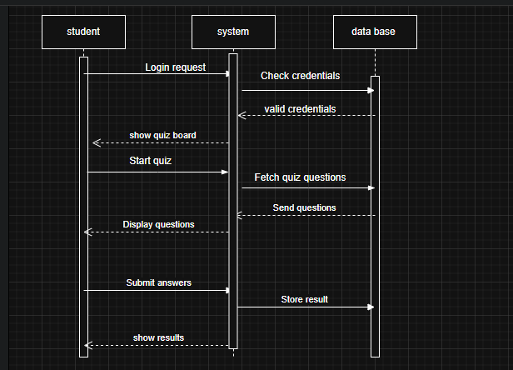

<https://drive.google.com/file/d/16xTztiVGFnFLahEDR3VCof5b3Mu8Uw6a/view?usp=sharing>

<https://drive.google.com/file/d/1U8M1wHdZA3cN-5Qx1LpEgEFvhTG_1jRF/view?usp=sharing>

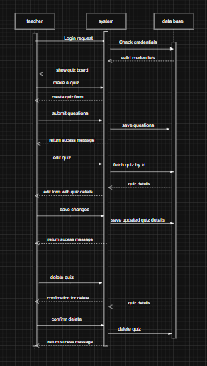

# Canva link:

https://www.canva.com/design/DAGotrQ5VpQ/Gbaf-z3cMM7vTm40Ehrwog/edit?utm_content=DAGotrQ5VpQ&utm_campaign=designshare&utm_medium=link2&utm_source=sharebutton